Chapter 1, Solution 6

(a) At t = 1ms, 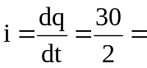 15 A

(b) At t = 6ms, 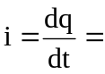 0 A

(c) At t = 10ms, 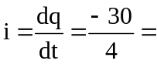 –7.5 A

